ERD Table

|  |  |
| --- | --- |
| TableName | Attribute |
| Customer | CustomerID: integer {PrimaryKey}  CustomerName: string  CustomerAddress: string  CustomerCity: string  CustomerState: string  CustomerCountry: string  CustomerPhoneNumber: integer  CustomerEmail: string |
| Product | ProductID: integer {PrimaryKey}  Description: String  Type: string  Material: string  Style: string  Quantity: integer  Rating: integer  Name: string  Size: char/string/integers  Type of service: string |
| Partner | PartnerID: integer {Primary Key}  PartnerName: string  PartnerAddress: string  PartnerCity: string  PartnerState: string  PartnerCountry: string  PartnerPhoneNumber: integer  SkillRating: integer |
| ProductImage | IDimage: integer {PrimaryKey}  ImagePostedDate: integer  CustomerID: integer {Foregin Key}  PartnerID: integer {Foreign Key}  ProductID: integer {Foreign Key} |
| TransactionTracking | TrackingNumber: integer {PrimaryKey}  OrderDate: integer  PickupDate: integer  SentDate: integer  ArrivalDate: integer |
| ProductVideo | IDVideo: integer {PrimaryKey}  VideoPostedDate: integer  CustomerID: integer {Foregin Key}  PartnerID: integer {Foreign Key}  ProductID: integer {Foreign Key} |
| SearchHistory | CustomerID: integer {Foreign Key}  SearchedDate: integer  SelectedProduct: string  ProductID: integer {Foreign Key}  SearchedText: string  SearchedTime: integer  SearchedDate: integer |
| PurchasedInfo | CustomerID: integer {Foreign Key}  CustomerName: string  CustomerAddress: string  CustomerCity: string  CustomerState: string  CustomerCountry: string  CustomerPhoneNumber : integer  CustomerEmail: string  CreditCardNumber: integer  ConfirmationNumber: integer {PrimaryKey} |
| Payment | CreditCardNumber: integer  CustomerID: integer {Foreign keys}  CustomerName: string |
| DirectPay | AccountNumber: integer  RoutingNumber: integer  PartnerID: integer {foreign key}  PartnerName: string  PaymentDate: integer  PaymentID: integer {Primary key} |

**Brandona software components diagram**

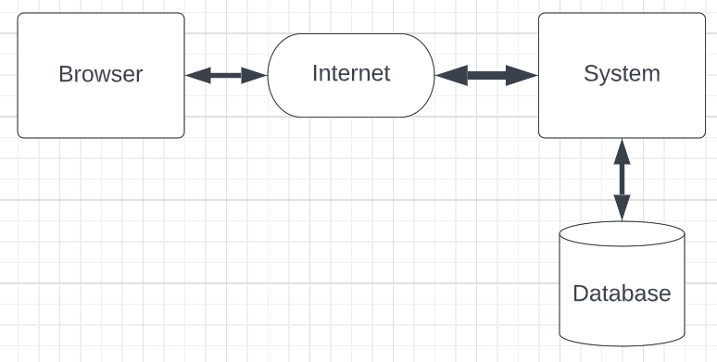

The diagram above illustrates the flow of data through the virtual machines. It starts with the database, where the system can retrieve or update information as needed. Users interact with the system through a browser over the internet. The browser sends requests to the system, which acts as a mediator, determining what data can be accessed or provided based on set limitations. Additionally, users can input data into the system, which then controls and validates the data before it is stored in the database, ensuring secure and efficient data management.

**Preliminary design class diagram**

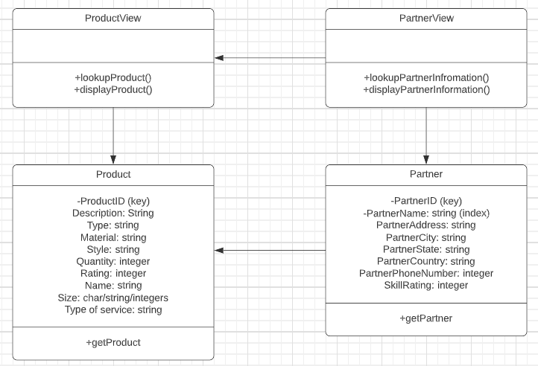

The diagram above depicts two tables: the **Partner** table and the **Product** table. The arrow indicates a relationship where the partner can access product information, either by looking it up or displaying it. This connection allows partners to interact with the product data as needed, enabling them to view or manage relevant information.

**Supplier Subsystem software architecture**

